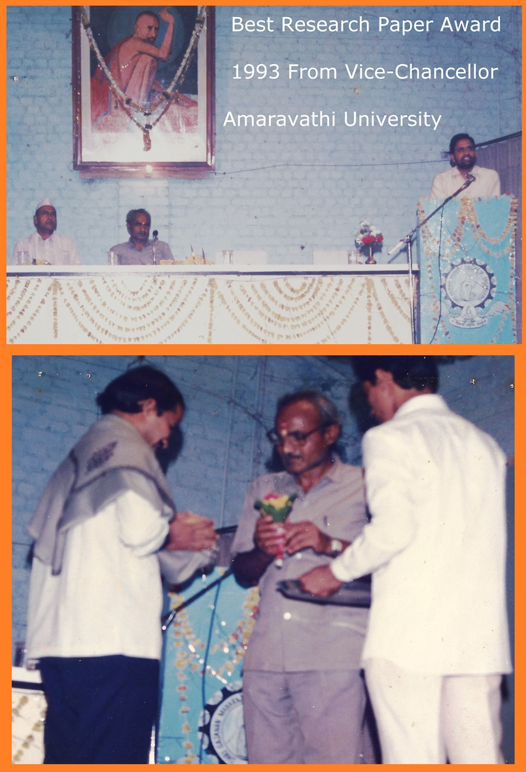Extraordinary Recognition in Artificial Intelligence Research

***"Only the deeds performed by a person accompany him."  
– Vice Chancellor Dr. Ganesh Patil***

# A Rare Academic Honor from Amaravati University

In a prestigious ceremony held at Shri Sant Gajanan Maharaj Engineering College (SSGMCE), Shegaon, Prof. Chandrashekar Swami was specially invited to present a scholarly report. During the event, he was felicitated by the Hon’ble Vice Chancellor of Amaravati University, Dr. G. V. Patil, in recognition of his remarkable contributions to scientific research.  
  
This moment was not only ceremonial but also symbolic of a deeper academic journey. Back in Aug, 1992, Prof. Swami achieved a historic distinction as the only scholar from a rural private engineering institution in India — SSGMCE, Shegaon — to be invited to present two research papers at the 18th IUPAP International Conference on Statistical Physics (STATPHYS-18), hosted at the Technical University of Berlin, Germany.

At that global event, only five scientists were invited from India, representing elite institutions like TIFR Bombay, JNU Delhi, and IIT Kanpur. Among them, four were from premier national research institutions, while Prof. Chandrashekar stood out as the sole participant from a lesser-known, rural engineering college — a testament to his exceptional research caliber and unwavering dedication to scientific inquiry.

Reflecting on this accomplishment, Prof. Chandrashekar humbly states:  
“The holy soil of Shegaon has blessed me immensely. Even today, the miraculous events of 1992 remain a divine mystery. When institutions like TIFR, JNU, and IITK were dominant names, who would have thought of SSGMCE? Yet, a miracle unfolded. Such events reinforce our deep-rooted faith in divine energy — where nothingness holds everything.”

His journey exemplifies how excellence in science can emerge from the most humble and unexpected corners of the academic world, driven by passion, perseverance, and the blessings of sacred inspiration.

# Endorsement by CEERI Scientist

Prof. Chandrashekar's pioneering work in AI-based Automatic Speech Recognition was endorsed by renowned Central Electronics Research Institute (CEERI), Scientist 'F', Dr. S. S. Agrawal, who strongly recommended his research as of high order, rare in India at the time.

